# Feature #1 Results

# Results for PWR – MOX done by IN2P3 with CLASS

**Reactor Description**

Thermal water reactor model in CLASS are built from a 17x17 standard PWR assembly geometry. The FLM uses neural network to predict the assembly infinite reactivity kinf. From the reconstructed evolution of the reactivity, the maximal Burn-Up is calculated when the current reactivity is below a reactivity threshold kth. In the case of a one third batching pattern, the kth used in the exercise is 1.034. For the calculations presented in this part, the core characteristics are:

* Heavy mass: 72 tons
* Thermal power: 3 GWth
* Irradiation time: 3 years that correspond to a burn-up closed to 34 GWd/t
* Loading factor: 75%

**Stock Pu Composition @ Beginning Of Cycle**

The Pu composition at Beginning Of Cycle (BOC) is sampled from a Latin Hyper Square (LHS) algorithm. In order to have a wide range of possibilities, following boundaries have been chosen:

|  |  |  |
| --- | --- | --- |
| Isotope | Min. Frac. In Pu (Mass %) | Max. Frac. In Pu (Mass %) |
| 238Pu | 0 | 10 |
| 239Pu | 13 | 100 |
| 240Pu | 0 | 30 |
| 241Pu | 0 | 20 |
| 242Pu | 0 | 20 |
| 241Am | 0 | 7 |

All isotopes but 239Pu are sampled and the 239Pu is deduced as the complement to one. From such a design of experiment, some composition may be outside from CLASS model authorized composition for PWR-MOX fuel. Those compositions are excluded from the further developments.

The Design Of Experiment (DOE) is composed of 1000 simulations. The LHS used both for the FLM and FF approach is represented on the Figure 1. As we can see, 239Pu is correlated to other isotopes, due to the normalization of isotopes of plutonium to one.

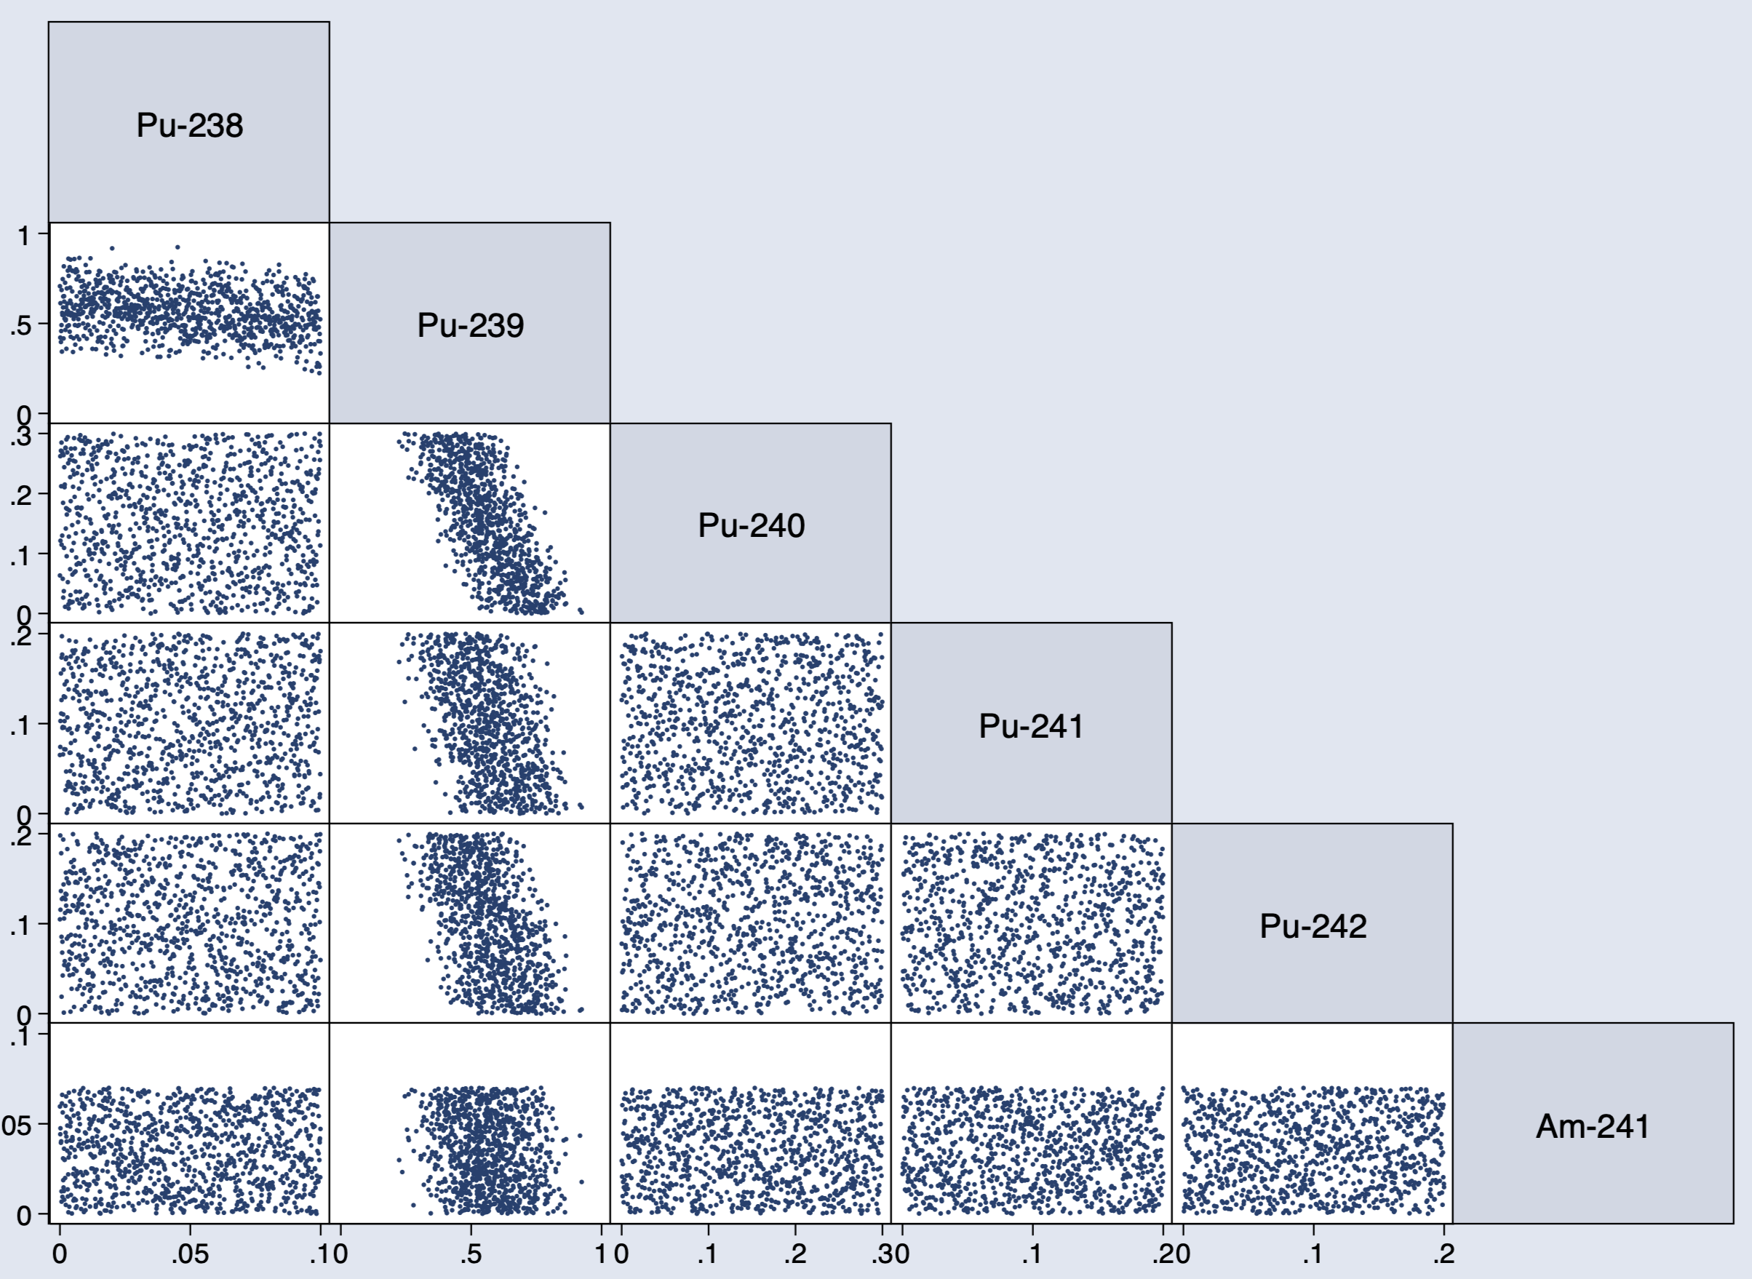

Figure 1: Matrix plot of the Latin Hyper Space obtained from 1000 compositions at BOC.

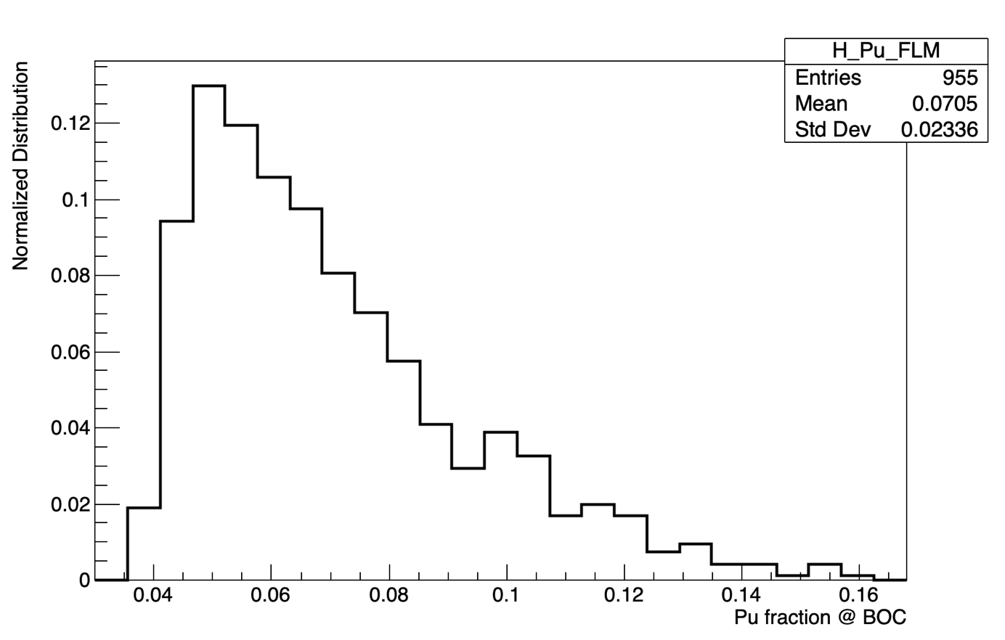

Figure 2 : Plutonium fraction in the fresh fuel at beginning of cycle.

**Methodology description**

The first step consists to run the 1000 simulations with the FLM approach. In this case, for each simulation, the plutonium fraction is calculated so that the expected Burn-Up (around 34 GWd/t) could be achieved. The plutonium fraction distribution at BOC for all the FLM runs is showed on Figure 2. As we can see in the statistics information, there is only 955 simulations represented instead of 1000. Some simulations have unloaded reactors because the plutonium composition was outside from the allowed boundaries of the FLM. We also note that the mean value of plutonium fraction is:

$$〈\frac{M(Pu)}{M_{0}}〉=7.05\%$$

This value will be used to run the same design of experiment but with a fixed fraction of plutonium in the fuel. At this step, we have two sets of simulations, one that has been run from FLM and the other one from FF approach. Those two sets will be compared in order to quantify the impact of using a FLM rather than a FF model.

**Data analysis**

In this part, we present some data analysis of the FLM simulations in order to understand the physics at the basis of the sample. The Figure 3 shows causal links between variables. The first variable is the fissile fraction, calculated as following:

$$τ_{fissile}=\frac{{}_{.}^{239}{Pu}+{}_{.}^{241}{Pu}}{\sum{Pu}}$$

This variable is deduced from the LHS sample. As we can see on limit values, the fissile fraction ranges between 45% and 90% in the LHS. The middle variable of the figure is the plutonium fraction at BOC calculated as the ratio between plutonium mass and initial heavy mass. This variable is calculated from the FLM in CLASS according to the plutonium composition. Plutonium fraction lies between 4% and 16%. The third variable is the plutonium relative difference between BOC and EOC. This variable is between 12% and 30% which shows the maximal deviation of the plutonium relative slope during a reactor evolution. The last variable is the plutonium absolute difference between BOC and EOC divided by the reactor cycle time. This variable lower limit is around 0.25 tons / year and the higher limit closed to 0.50 tons per year.

Some ranges have been imposed in order to highlight pathways of the matrix plot. If the fissile fraction (purple line) is lower than 50%, the plutonium fraction in the fuel is high and thus, the plutonium relative difference is high. This is due to the initial mass effect that is more important than the absolute slope effect. Finally, this produce a high plutonium absolute difference between BOC and EOC. As the plutonium fraction is high, the absolute slope is higher as well.

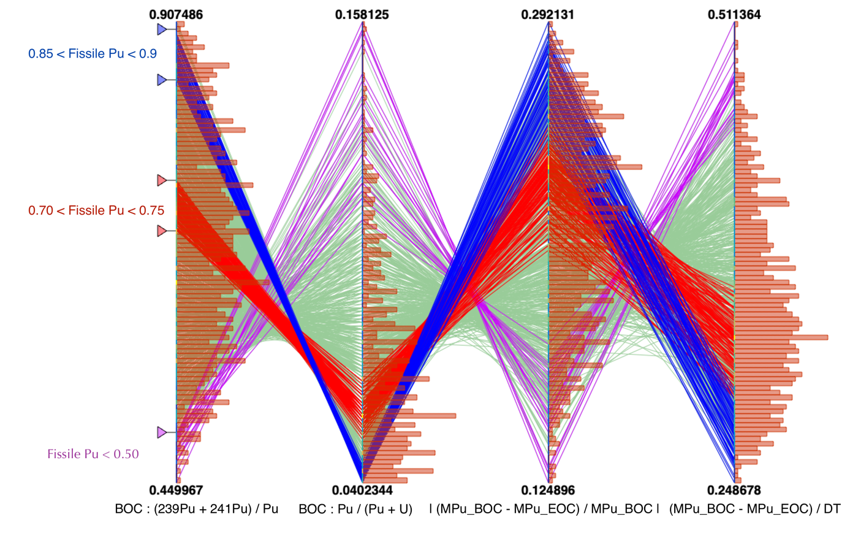

Figure 3: Parametric plot representing Fissile plutonium fraction in Pu, plutonium fraction in the fuel, plutonium relative variation between BOC and EOC and plutonium slope in ton/year. Some specific ranges have been added.

**Output metric**

Here, we present the output metric used to compare FLM and FF simulations. The aim is to build estimators that provide the order of magnitude of the FLM impact compared to FF approach as simply as possible.

Estimator #1

The first estimator is chosen to get the impact on specific facilities of the fuel cycle. For each simulation “i”, the following factor that represents the plutonium fraction at BOC is calculated as follow:

$$F\left({Pu}_{i}\right)=\frac{{Pu}_{l}^{BOC}}{M_{HN}}$$

From this parameter, the relative variation of FLM compared to FF approach is calculated as follow:

$$δF\left({Pu}_{i}\right)=\frac{F_{FLM}\left({Pu}_{i}\right)-F_{FF}({Pu}_{i})}{F_{FF}({Pu}_{i})}$$

This parameter shows the relative deviation between the plutonium fraction that feed the reactor at BOC for FLM et FF approach. The higher this parameter is, the higher the impact of FLM compared to FF approach is. This parameter has been calculated for each simulations i if the DOE. The produced distribution for all simulations is represented on Figure 4. For instance, if $δF\left(Pu\right)$ is 100%, that means that the plutonium fraction required to load the PWR is 100% higher for the FLM compared to FF approach, here 7.05 x 2 = 14.10%. It is possible to retrieve, from the definition of $δF\left({Pu}_{i}\right)$, the boundaries of this plot (i.e. -40% until 120%) from the boundaries of the FLM model which is between 4% and 16% of plutonium in the fuel.

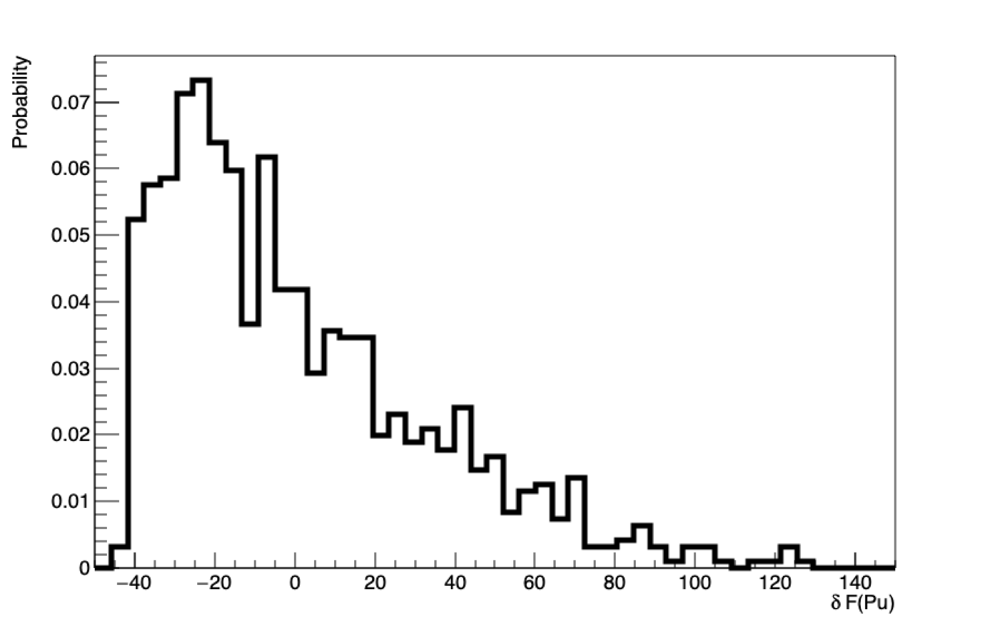

Figure 4: Relative plutonium fraction deviation between FLM and FF approach distribution. The deviation is plotted in %.

The plot on the Figure 4 shows that on a wide range of different plutonium vectors, the FLM is fully required to properly reproduce all the material stock involved in the PWR-MOX cycle. Nevertheless, there is no information related to the impact of the FLM approach on aggregated variables, such as total plutonium production in the nuclear cycle.

Estimator #2

The second estimator aims to take into account the slope of the materials evolution. We focus here on plutonium. There’s two ways to compute an estimator of the slope. The first one, described here, is the relative slope defined as following:

$$\frac{∆M}{M}\left({Pu}_{i}\right)=\frac{M^{BOC}\left({Pu}_{i}\right)-M^{EOC}({Pu}_{i})}{M^{BOC}\left({Pu}_{i}\right)}$$

The second way to define an estimator of the slope is to use the derivative of the plutonium mass over time on the reactor cycle. This approach will be described in the next paragraph. From the relative mass variation, we define the following estimator:

$$δ\frac{∆M}{M}({Pu}_{i}) = \frac{{\frac{∆M}{M}}_{FLM}\left({Pu}_{i}\right)-{\frac{∆M}{M}}_{FF}\left({Pu}_{i}\right) }{{\frac{∆M}{M}}_{FF}\left({Pu}_{i}\right)}$$

This estimator quantifies the relative slope variation between FLM and FF approach. If the estimator is zero, that means that FLM and FF calculations have the same relative slope during the reactor cycle. If the estimator is higher than 0 (resp. lower than 0), the FLM approach burns a higher (resp. a lower) quantity of plutonium in relative terms. The Figure 5 shows for all the simulations of the set the estimator 2 defined above.

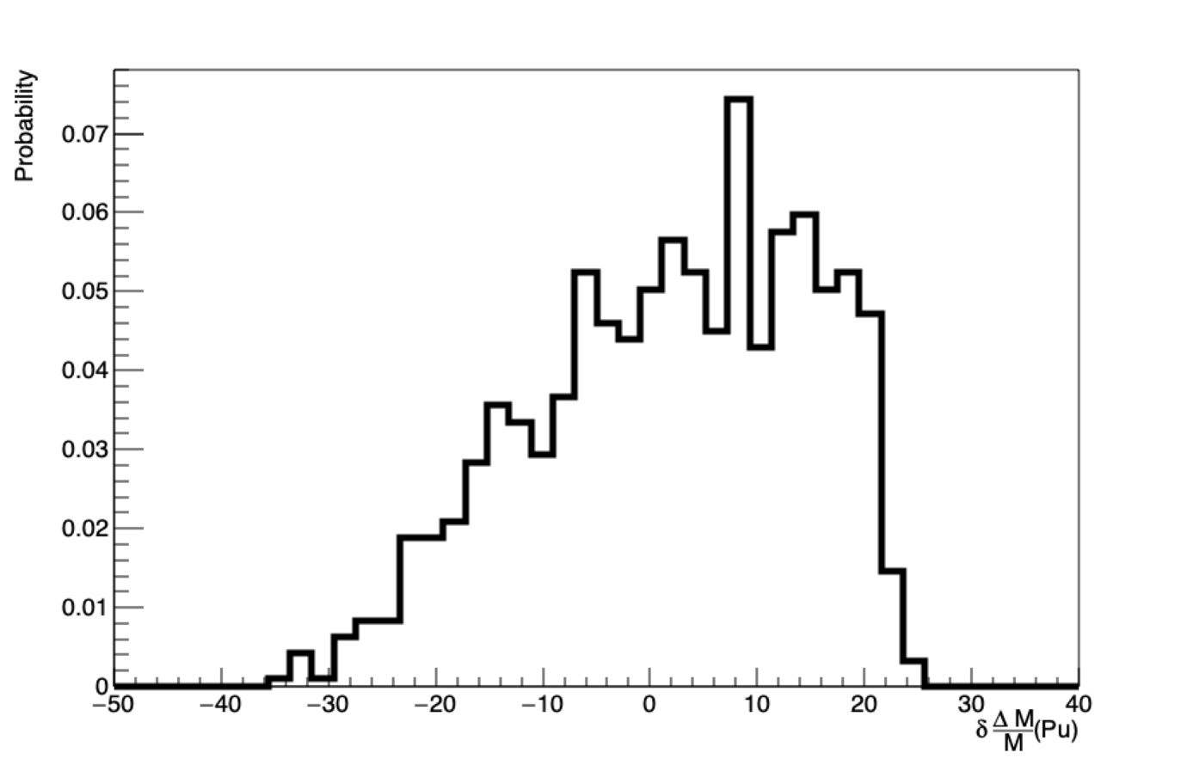

Figure 5: Estimator 2 normalized distribution in % for all the simulations.

Estimator 2 ranges between -35% up to 25%. That means relative mass slope during a reactor cycle may be highly different whether using a FLM or a FF.

Estimator #3

The third estimator is based on the derivative of the plutonium mass over time on the reactor cycle:

$$\frac{∆M}{∆t}\left({Pu}_{i}\right)=\frac{M^{BOC}\left({Pu}_{i}\right)-M^{EOC}({Pu}_{i})}{∆t}$$

Where $∆t$ is the reactor cycle time. The estimator 3 is then computed as follow:

$$δ\frac{∆M}{∆t}({Pu}_{i}) = \frac{{\frac{∆M}{∆t}}_{FLM}\left({Pu}_{i}\right)-{\frac{∆M}{∆t}}_{FF}\left({Pu}_{i}\right) }{{\frac{∆M}{∆t}}_{FF}\left({Pu}_{i}\right)}$$

This estimator is an estimation of the slope absolute variations between FLM and FF simulations. The slope represents the plutonium quantity that is consumed in the fuel cycle. The plot representing the distribution of estimator 3 for all simulations is showed on Figure 6:

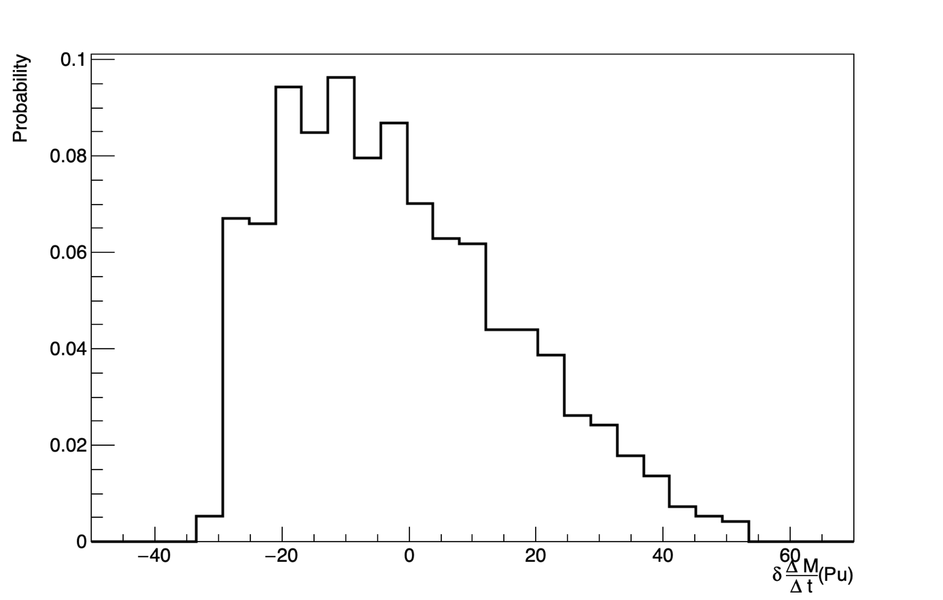

Figure 6: Estimator 3 normalized distribution in % for all the simulations.

Estimator 3 lower limit is -35% which correspond to a simulation for which FLM plutonium slope is 35% smaller than the FF slope. The higher limit is around 50%. This distribution shows that absolute plutonium mass slope during a reactor cycle may be highly different whether using a FLM or a FF. This tends to show that FLM is required if plutonium vector isotopic composition has wide variations.

**Temporary Conclusion**

The results related to feature #1 done by IN2P3 with the CLASS code simulating PWR-MOX fuel aims to show that each estimator distributions are relatively wide. This shows that in the framework of the design of experiment used to solve this exercise, FLM approach seems to have a huge impact on plutonium inventory in the cycle and/or in facilities.

# Results for Cyclus – PWR MOX

**Reactor Description**

The reactor model used for this analysis, is based on the CLASS model to compute fuel depletion based on reaction’s cross sections predicted using neural networks. The reactor configuration/model is the same as the one described in the CLASS part of the exercise. The reactor settings are slightly different than the one used in the CLASS work:

* Heavy mass: 72 tons
* Thermal power: 2.7 GWth
* Burnup at the end of irradiation: 41.09 GWd/t
* Loading factor: 100%

**Stock Pu Composition @ Beginning Of Cycle**

The Pu composition at Beginning Of Cycle (BOC) is sampled from a Latin Hyper Square (LHS) algorithm. The following isotopic space/limits have been used to sample the LHS:

|  |  |  |
| --- | --- | --- |
| Isotope | Min. Frac. In Pu (Mass %) | Max. Frac. In Pu (Mass %) |
| 238Pu | 0 | 7.5 |
| 240Pu | 10 | 30 |
| 241Pu | 0 | 20 |
| 242Pu | 0 | 20 |
| 241Am | 0 | 7 |

The 239Pu is used as the buffer to ensure the normalization of the plutonium composition. 1000 simulations with plutonium composition have been sampled.

**Methodology description**

* Fuel loading Model:

The fuel loading model used is based on the Baker & Ross, (Equivalent plutonium theory), attempting to reproduce the reactivity of the reference fuel (4.5% of 239Pu) using the available plutonium.

Predicted fuel fractions ranged between 5% and 15% of plutonium in the fuel.

On Figure 1 on can observe on the upper triangle the distribution of the plutonium compositions (one plutonium versus another), on the diagonal the distribution each plutonium isotope individually, and on the lower diagonal, the plutonium fraction predicted by the model for each plutonium composition.

* Fixed Fraction:

The fixed fraction used for this work correspond to the mean plutonium fraction of predicted by the B&R Pu-equivalent theory (same reference as previously) on additional 100 random plutonium compositions of been generated (on a LHS). The used fixed fraction is 7.807%.

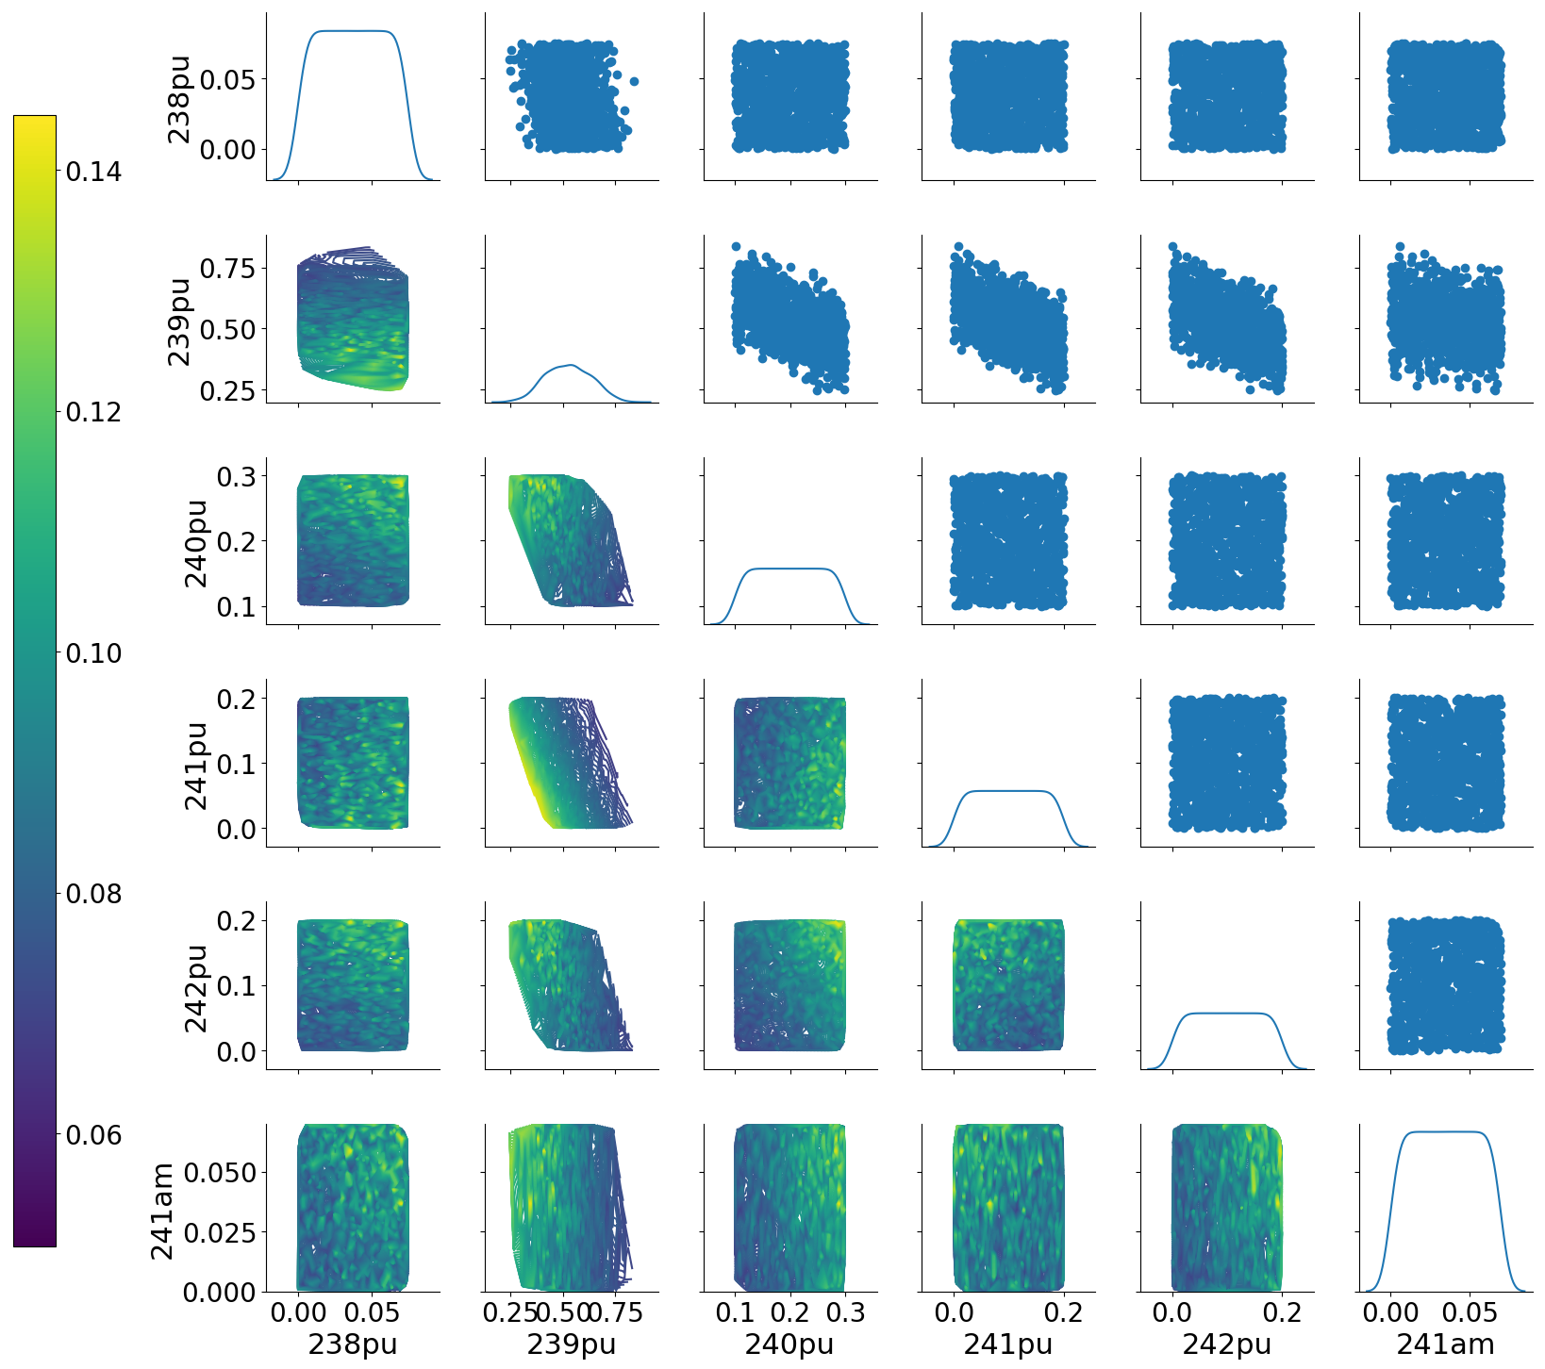

Figure 1 : Plutonium fraction in the fresh fuel at beginning of cycle.

**Data analysis**

**Output metric**

The output metrics defined in CLASS analysis have been used (estimator #1, #2, #3).

For all three estimators, similar conclusions as the CLASS PWR MOX analysis can be reached.

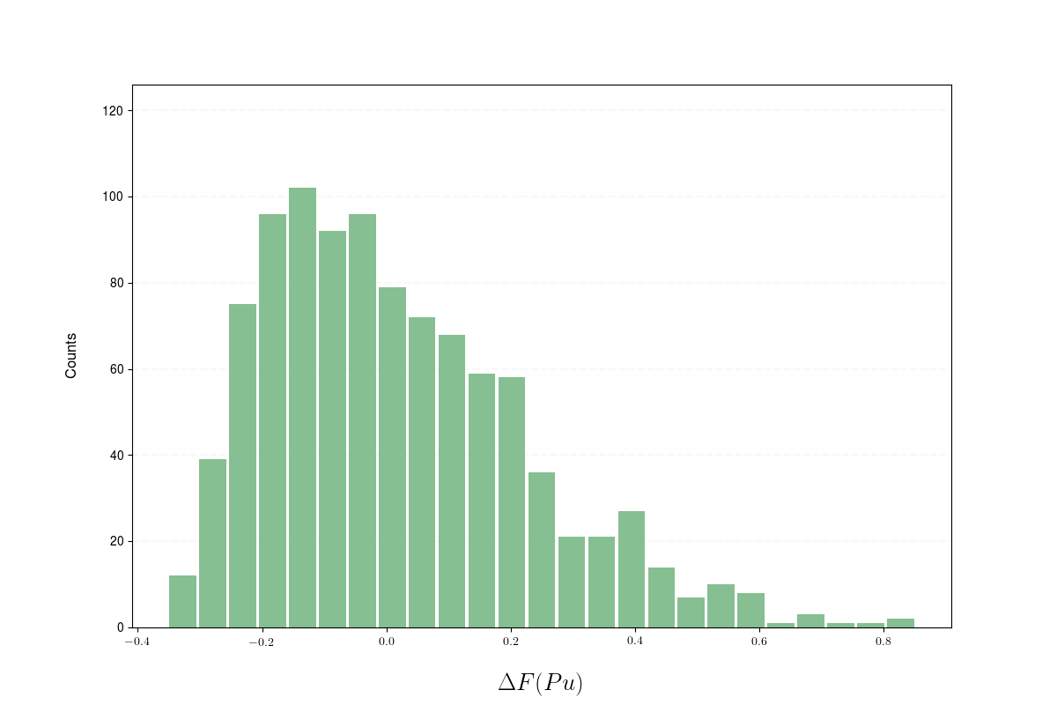

Figure 2: Estimator#1 Relative plutonium fraction deviation between FLM and FF approach distribution. The deviation is plotted in %.

A variation ranging between - 20% and 80% (relative to the fixed fraction) can be observed between the fixed fraction and the plutonium equivalent model. This effect might lead to variation on the localization of the plutonium stock, moving it from the upstream storage (with respect to the reactors) to the downstream storage.

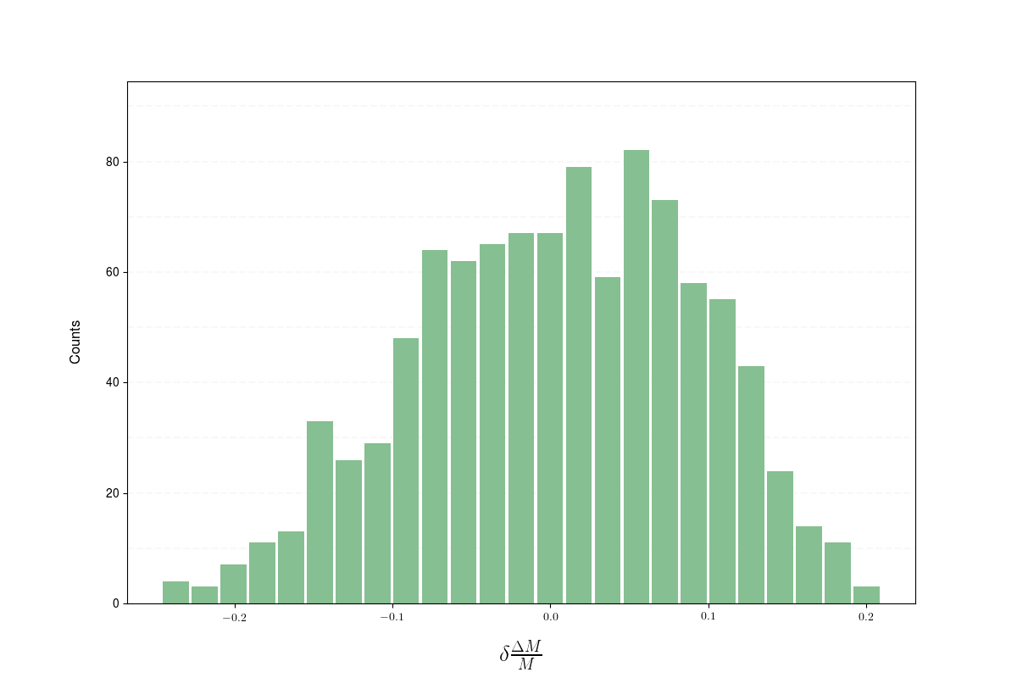

Figure 3: Estimator 2 normalized distribution in % for all the simulations.

As for the CLASS analysis, the relative amount of plutonium burnup in the reactor varies from -20 to +20% (relative to amount burned in the fixed fraction case) — see Figure 3.

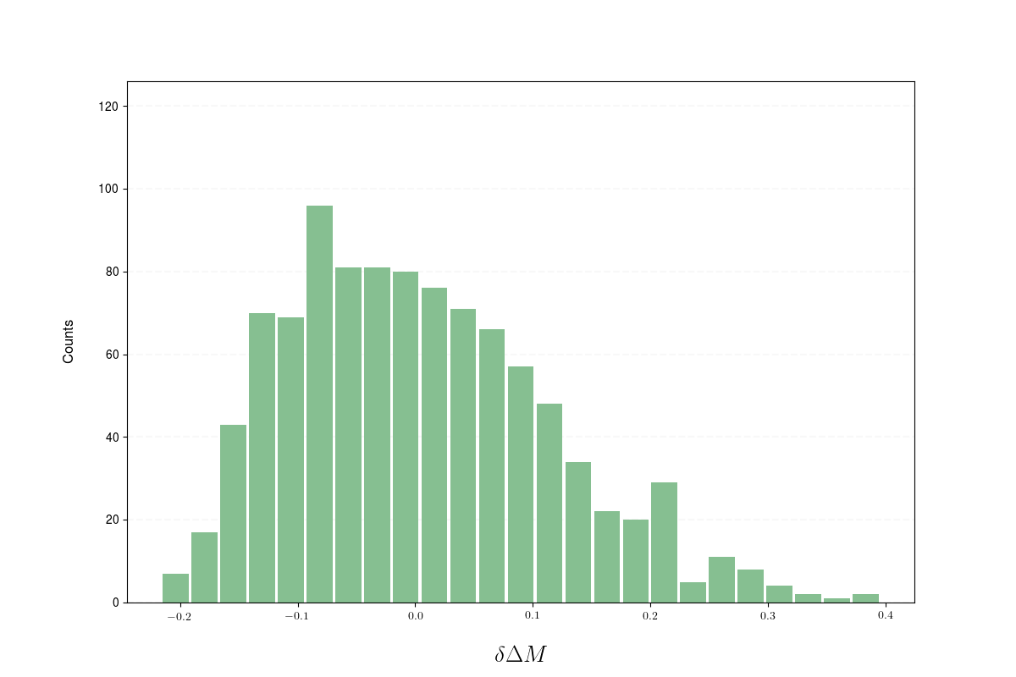

Figure 4: Estimator 3 normalized distribution in % for all the simulations.

Finally, the discrepancy for the mass of plutonium burned, variation goes form -20% to 40% (relative to the plutonium mass burned in the fixed fraction case) — see Figure 4.

This might impact strongly the total amount of plutonium present in simulation.

**Plutonium Composition**

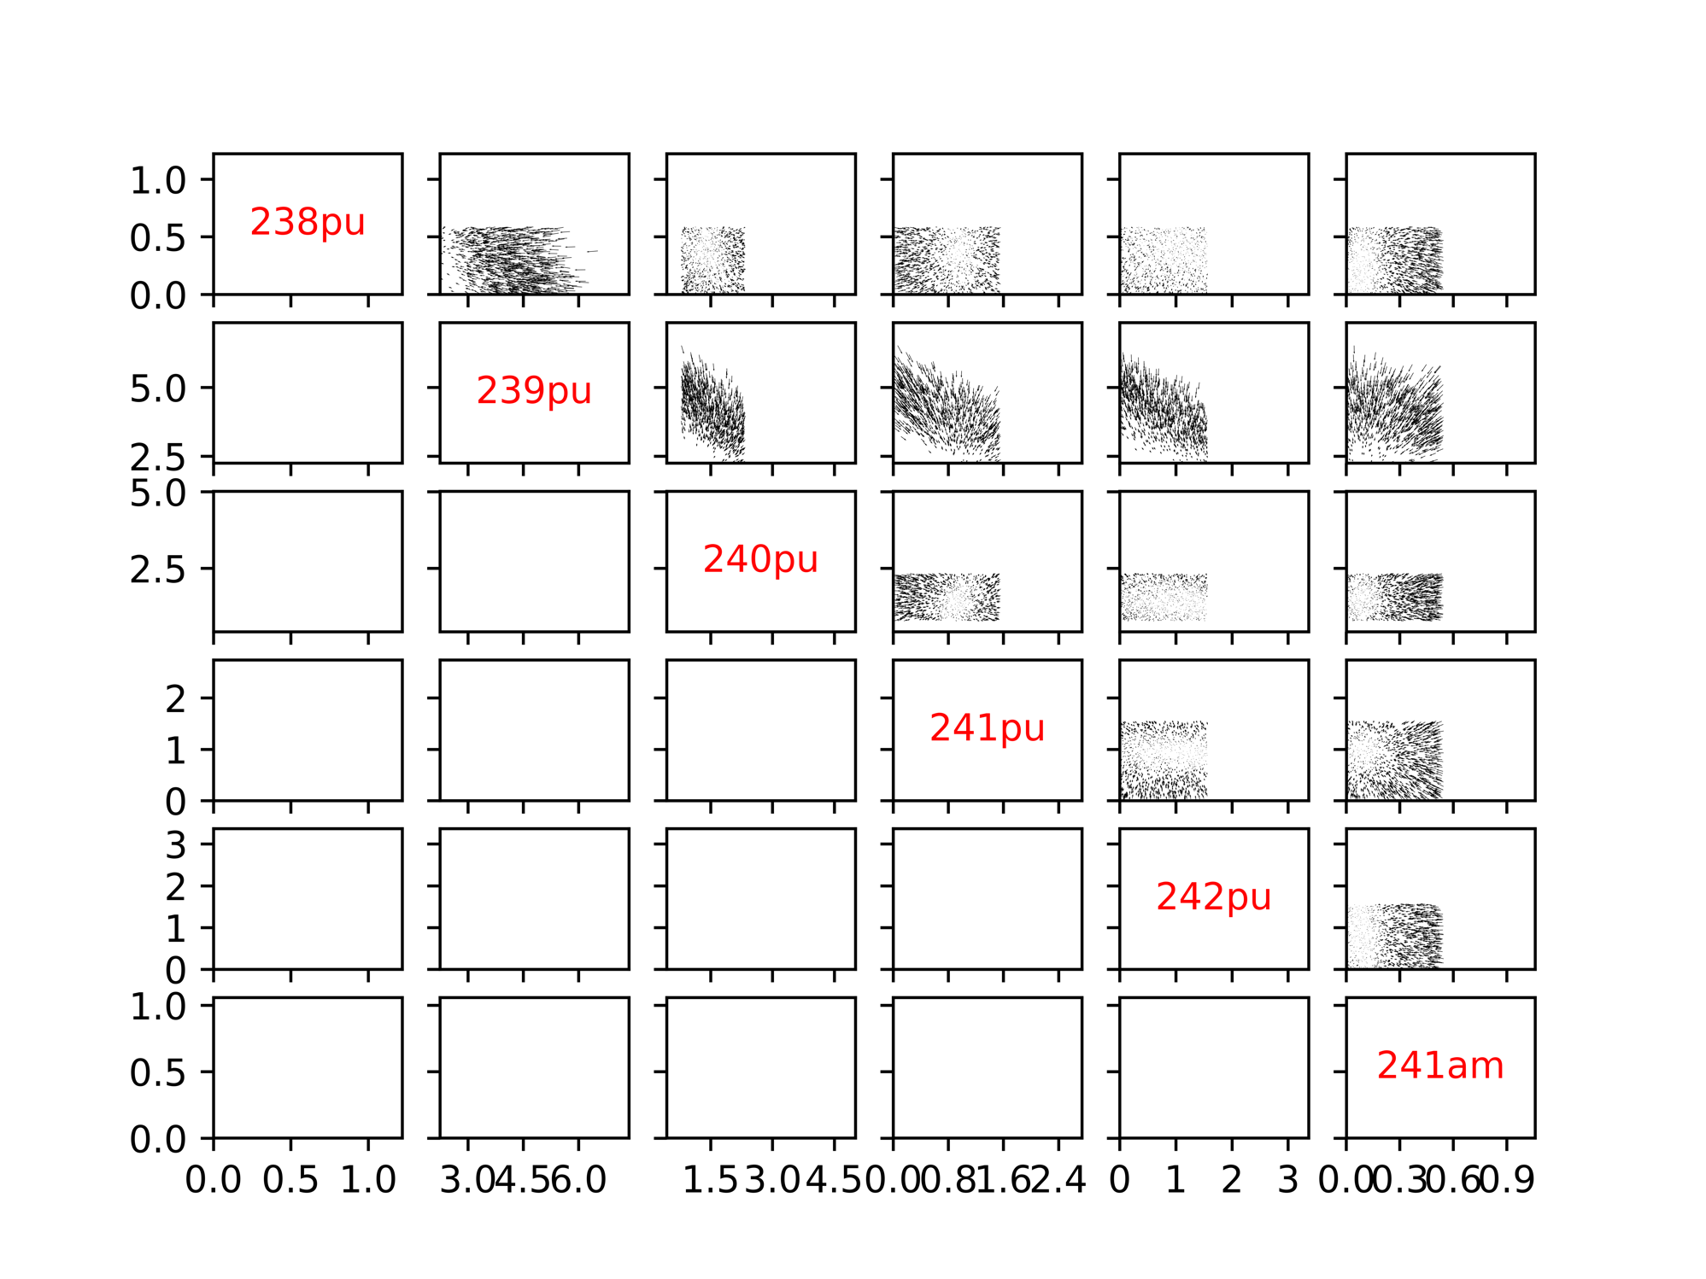

Figure 5:Fix fraction, Plutonium Isotopes fractions evolution (vector scale 1/10)

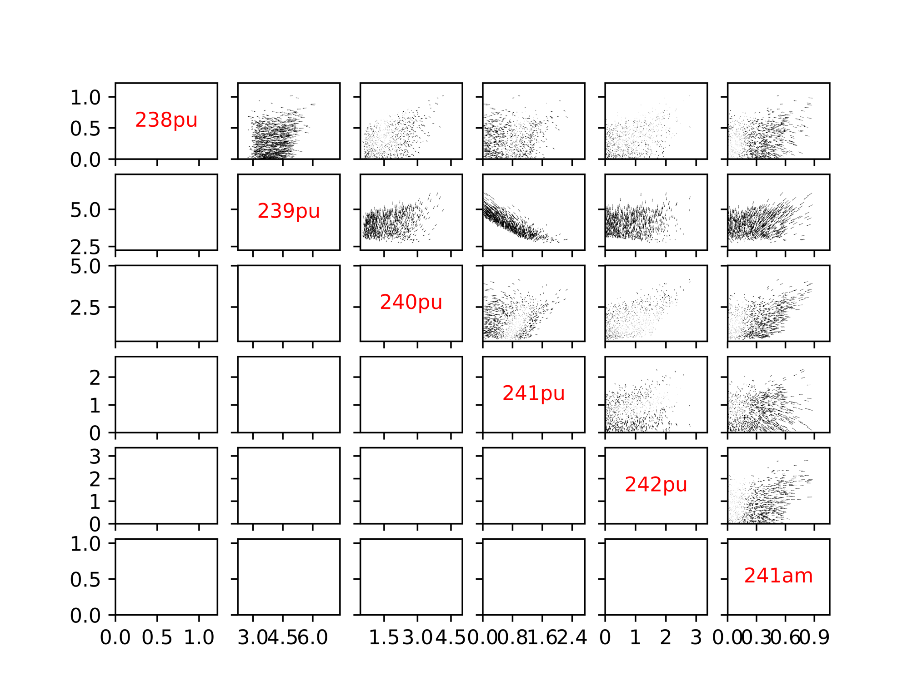

Figure 6:Pu-Equivalent Model, Plutonium Isotopes fractions evolution (vector scale 1/10)

Figure 5 and 6 can be found in hight resolution there:

Fig.5: https://github.com/bam241/fit_cyclus/raw/F01/F01/run_1/Variation_fix.png

Fig.6: https://github.com/bam241/fit_cyclus/raw/F01/F01/run_1/Variation_eq.png

Figures 5 and 6 confirm that the equilibrium composition of the plutonium in the considered reactor are the same, head toward to the same values regardless to the initial plutonium composition or fraction.

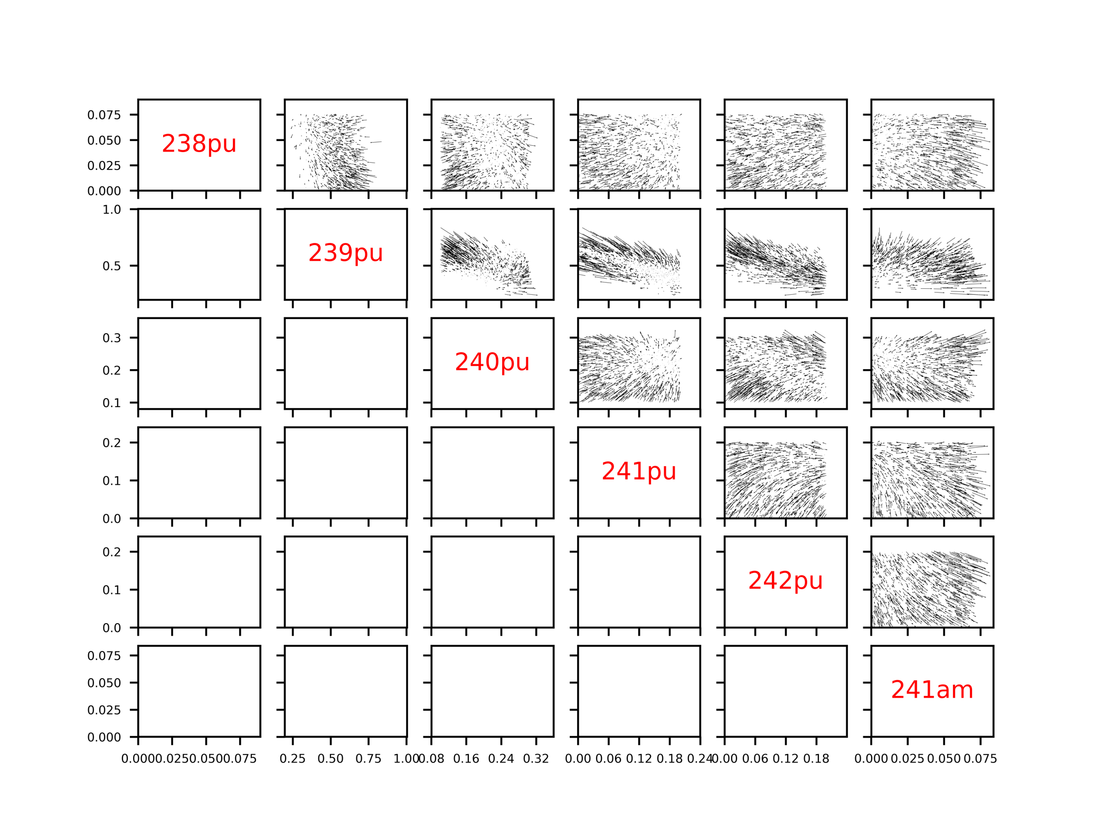

Figure 7: Plutonium Isotopes composition differences (FF – EqPu) as a function of the Pu initial composition

Fig.7 can be found in higher resolution here:

https://github.com/bam241/fit_cyclus/raw/F01/F01/run_1/Variation_pu_eoc.png

As shown on figure 7. using a fixed fraction instead of a fuel fabrication model, will have an impact on the plutonium composition at the end of the cycle. Depending of the scenario (reprocessing of the MOX spent fuel… ) using a fixed fraction might have a snowball effect on the rest of the simulation. One can observe up to 25% variation on the 238Pu isotopic fraction, 10% on the 239Pu, 15% on the 240Pu, 25% on the 241Pu, 84% on the 242Pu and 58% on the 241Am…

# Results for IN2P3 / CLASS – ESFR MOX

**Reactor Description**

Several design of sodium fast cooled reactor are implemented in the CLASS package and for this first work, we chose the European Sodium Fast Reactor design. The reactor is modeled thanks to full core depletion calculations and the FLM uses neural network to predict the effective reactivity keff at beginning of cycle (BOC). The chosen value is set arbitrarily at 1.01 with a 0.01 reactivity margin that should take into account extra neutron losses the model does not take into account.

For the calculations presented in this part, the core characteristics are:

* Heavy mass: 72 tons
* Thermal power: 3 GWth
* Irradiation time: 7 years that correspond to a burn-up closed to 80 GWd/t
* Loading factor: 75%

The plutonium enrichment inside the fuel is limited between 12% and 22% according the model validity and the reference ESFR calculation, with the composition mainly used in the literature, shows a typical enrichment of 16%.

**Stock Pu Composition @ Beginning Of Cycle**

The sampling for different plutonium composition at BOC is exactly the same as the one used for the PWR example in the previous section. A thousand compositions have been sampled and represented in Figure 1.

**Methodology description**

For the resolution of the exercice 1 of the FIT benchmark, we have applied the following methodology:

* First, the thousand fuel cycle calculation have been performed with the Fuel Loading Model (FLM). For each cycle calculation the Fuel Loading Model calculate the plutonium enrichment function of the plutonium isotopic vector.
* Over the thousand calculation, 736 have succeed. The failed calculations correspond to plutonium isotopic compositions that lead to plutonium enrichment over the model domain validity (which is [12%;22%]).
* In a second time, the same calculations have been performed with a fixed plutonium fraction chosen arbitrarily at 16%. In those calculation, the plutonium enrichment is always the same with no regards to the isotopic composition of the plutonium.
* Finally, results are compared between them by comparing the same calculation with FLM and without.

**Data analysis**

Results of the FLM calculations are represented in Figure 8. The first column represents the fissile fraction inside the plutonium loaded in the reactor, the second column is the plutonium fraction in the fuel at BOC, the third column is the relative balance of the plutonium expressed as $\frac{Pu^{BOC}-Pu^{EOC}}{Pu^{BOC}}$, and the last column represents the time derivative of the plutonium composition as in $\frac{Pu^{BOC}-Pu^{EOC}}{T_{cycle}}$, where $T_{cycle}$ is the irradiation time (here, 7 years).

As we can see in the parallel plot, if the fissile fraction in the plutonium is high, then the plutonium enrichment in the fuel is rather small. In that case, the reactor behaves as a plutonium breeder as the third and fourth column show negative value (the plutonium quantity at EOC is higher than the plutonium quantity at BOC.

On the contrary, when the highest value for plutonium enrichment are reached when the fissile fraction in the plutonium is rather low. In that case, the reactor behaves as a plutonium breeder. Those observations are classical observation of fast reactor fuel evolutions.

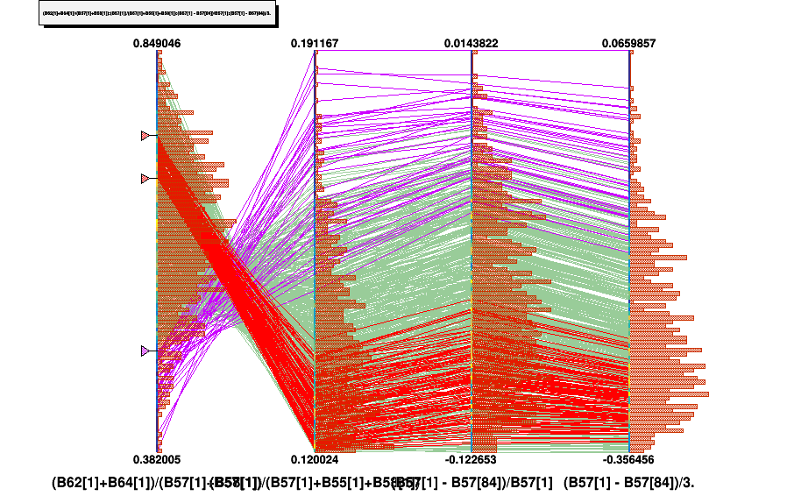

Figure 8: Parametric plot representing Fissile plutonium fraction in Pu, plutonium fraction in the fuel, plutonium relative balance between BOC and EOC (third column) and the time derivative of the plutonium composition over irradiation (fourth column). Some specific ranges have been added.

**Output metric**

Estimator #1

The first estimator is chosen, as in the previous section. The idea is to quantify the impact of the fuel loading model on the plutonium enrichment at beginning of cycle. This plutonium enrichment is directly linked to fuel processing facilities flows. We define the enrichment as

$$F\left({Pu}_{i}\right)=\frac{{Pu}_{l}^{BOC}}{M_{HN}}$$

To quantify the impact of our FLM, we calculate the relative difference of this plutonium enrichment in the fresh fuel with and without the FLM as the following expression. The chosen reference value is the fixed fraction as it is a constant over all the simulations.

$$δF\left({Pu}_{i}\right)=\frac{F_{FLM}\left({Pu}_{i}\right)-F_{FF}({Pu}_{i})}{F_{FF}({Pu}_{i})}$$

The histogram of $δF\left({Pu}_{i}\right)$ is presented in Figure 9. Several observations should be made:

* The deviation distribution is not centered on 0. This means that the chosen fixed fraction (16%) is not exactly the average of the plutonium enrichment given by the fuel loading model regarding the possible initial compositions.
* The discontinuity of the deviation histogram is due to the limitation of the model domain validity. It is not possible to load less than 12% of plutonium in the fresh fuel. If the plutonium isotopic composition is very enriched in fissile isotope (as it is probable in the LHS sampling), the plutonium fraction may be lower than 12% and in that case, the reactor is not loaded.

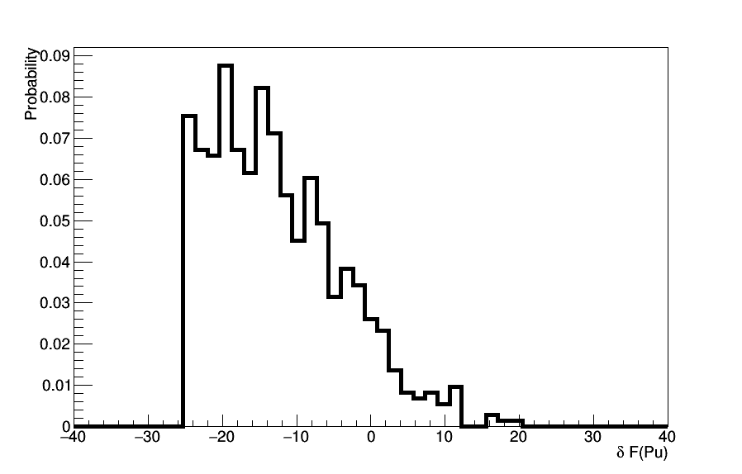

Figure 9: histogram of plutonium enrichment deviations when considering a fuel loading model for ESFR

From that picture, the importance of the FLM for Sodium Fast Reactor is pretty clear. A 10% deviation over the plutonium initial enrichment means a bias of approximately 1.5 tons for a 1.4 GWe rector. The deviations of plutonium enrichment at BOC are less of importance than in the case of PWR but, as the plutonium mass inside a fast reactor is much higher than in a PWR, the range of plutonium mass bias at loading are the same order of magnitude.

Estimator #2.b

The second chosen estimator is different from the estimator #2 from the previous section. Indeed, the ESFR reactor concept has been design to be plutonium breeder. Then, in some of our calculations, the plutonium quantity at EOC is the same than at BOC leading to a time derivative of plutonium quantity equal to 0. In that case, the relative consumption of plutonium is also equal to 0. In order to avoid division by 0, we consider only differences between the plutonium incineration with and without FLM.

The plutonium incineration rate is defined as :

$$\frac{∆M}{∆t}\left({Pu}_{i}\right)=\frac{M^{BOC}\left({Pu}_{i}\right)-M^{EOC}({Pu}_{i})}{∆t}$$

The estimator #2.b is then defined as :

$$δ\frac{∆M}{M}({Pu}_{i}) = {\frac{∆M}{M}}_{FLM}\left({Pu}_{i}\right)-{\frac{∆M}{M}}_{FF}\left({Pu}_{i}\right)$$

The distribution of this estimator over our calculations is plotted in Figure 10. As we can see, the deviation can be very important (over 50%). In order to see such an impact, let’s consider an example. We consider a case where the FF calculation shows a break-even reactor, ${\frac{∆M}{M}}_{FF}\left({Pu}_{i}\right)$ is then equal to 0. A deviation of -50% on estimator #2.b means that the calculation with a FLM shows a reactor where the plutonium quantity decrease by a factor 2 over the irradiation. For the next loading, half of the plutonium quantity needed for the reactor loading should be taken from stocks. The impact of the FLM on the fuel cycle is then of first importance.

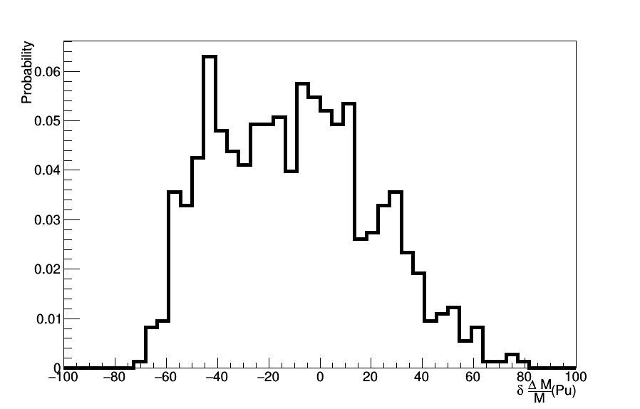

Figure 10: Estimator 2.b normalized distribution in % for all the simulations.

**Temporary Conclusion**

The results related to feature #1 done by IN2P3 with the CLASS code simulating ESFR-MOX fuel aims to show that the use of a Fixed Fraction of plutonium in the fresh fuel lead to strong bias in the plutonium quantity needed as in the plutonium production during irradiation. In the framework of the design of experiment used to solve this exercise, FLM approach seems to have a huge impact on plutonium inventory in the whole fuel cycle.